English

Lost in Time:

Introduction to

Literature

Reader

with

literary terms,

information

and assignments

English department

Introductory assignment: Defining literature.

A. Is this literature? Read the following text fragments and

a) Tick the box if you think the fragment is from a work of literature.
b) Write down what type of text you think it is (newspaper article, novel, poem, etc.). Motivate your answer!

1.
For sale. Baby shoes. Never worn.

a)
b) __________________________________________________________
__________________________________________________________
c) Optional: Write your own six-word story.

2.
Five score years ago, a great American, in whose symbolic shadow we stand signed the Emancipation Proclamation. This momentous decree came as a great beacon light of hope to millions of Negro slaves who had been seared in the flames of withering injustice. It came as a joyous daybreak to end the long night of captivity.

a)
b) __________________________________________________________
__________________________________________________________

3.
Lost in time I can’t count the words
I said when I thought they went unheard
All of those harsh thoughts so unkind
‘Cause I wanted you

a)
b) __________________________________________________________
__________________________________________________________

4.
In July 2007, armed men entered the Democratic Republic of Congo's Virunga National Park and killed five critically endangered mountain gorillas at point-blank range, leaving the bodies where they fell.

a)
b) __________________________________________________________
__________________________________________________________

5.
Plop plop fizz fizz… oh what a relief it is!

a)
b) __________________________________________________________
__________________________________________________________

6.
There's nothing unusual about writers recycling material. They're a larcenous bunch; literature is an economy based almost entirely on theft.

a)
b) __________________________________________________________
__________________________________________________________

7.
I’m Nobody! Who are you?
Are you Nobody, too?
Then there’s a pair of us ⎯ Don’t tell!
They’d banish us, you know.

a)
b) __________________________________________________________
__________________________________________________________

B. Mind map
Make a mind map entitled ‘Literature’. When we discuss in class, add words that are discussed.

literature

C. The list
Now let’s do the impossible and try to define literature by writing down what criteria you think a work of literature must meet. What aspects make a piece of writing literature? Combine all your knowledge from previous literature lessons (any language) and bear in mind the different elements of writing (language, style, content, genres, etc.). Write down at least 4 criteria.

List of criteria - aspects of literature

- _____________________________________________________
- _____________________________________________________
- _____________________________________________________
- _____________________________________________________
- _____________________________________________________
- _____________________________________________________

D. Definition
Look up an English definition of literature. Write it down here and compare (and contrast) it to your own criteria.
Definition: ____________________________________________________________________________________________________________________________________________________

Compare/contrast:
____________________________________________________________________________________________________________________________________________________

Close reading
To do a close reading, you choose a specific passage and analyze it in fine detail, as if with a magnifying glass. You then comment on points of style and on your reactions as a reader. Close reading is important because it is the building block for larger analysis. Your thoughts evolve not from someone else's truth about the reading, but from your own observations. The more closely you can observe, the more original and exact your ideas will be. To begin your close reading, ask yourself several specific questions about the passage. The following questions are not a formula, but a starting point for your own thoughts. When you arrive at some answers, you are ready to organize and write. You should organize your close reading like any other kind of essay, paragraph by paragraph, but you can arrange it any way you like.

I. First Impressions:
- What is the first thing you notice about the passage?
- What is the second thing?
- Do the two things you noticed complement each other? Or contradict each other?
- What mood does the passage create in you? Why?

II. Vocabulary and Diction:
- Which words do you notice first? Why? What is noteworthy about this diction?
- How do the important words relate to one another?
- Do any words seem oddly used to you? Why?
- Do any words have double meanings? Do they have extra connotations?
- Look up any unfamiliar words.

III. Discerning Patterns:
- Does an image here remind you of an image elsewhere? Where? What's the connection?
- How might this image fit into the pattern of the literary work as a whole?
- Could this passage symbolize the entire work?
- What is the sentence rhythm like? Short and choppy or long and flowing? Does it build on itself or stay at an even pace? What is the style like?
- Look at the punctuation. Is there anything unusual about it?
- Is there any repetition within the passage? What is the effect of that?
- How many types of writing are in the passage? (For example: narration, description, argument, dialogue, rhymed or alliterative poetry, etc.)
- Can you identify paradoxes in the author's thought or subject?
- What is left out or kept silent? What would you expect the author to talk about that the author avoided?

IV. Point of View and Characterization:
- How does the passage make us react or think about any characters or events within the narrative?
- Are there colours, sounds, physical descriptions that appeal to the senses? Does this imagery form a pattern? Why might the author have chosen that color, sound or description?
- Who speaks in the passage? To whom does he or she speak? Does the narrator have a limited or partial point of view? Or does the narrator appear to be omniscient, and he knows things the characters couldn't possibly know? (For example, omniscient narrators might mention future historical events, events taking place "off stage," the thoughts and feelings of multiple characters, and so on).

V. Symbolism:
- Are there metaphors? What kinds?
- Is there one controlling metaphor? If not, how many different metaphors are there, and in what order do they occur? How might that be significant?
- How might objects represent something else?
- Do any of the objects, colors, animals, or plants appearing in the passage have traditional connotations or meaning? What about religious or biblical significance or references?
If there are multiple symbols in the work, could we read the entire passage as having allegorical meaning beyond the literal level?

Literary terms fiction

Term | Description
Narrator | The ‘voice’ telling the story. This can be either an ‘omniscient narrator’ (all-knowing) or a character within the story, who only has knowledge of what he or she has experienced/thought/felt, etc. within the story.
Perspective | I-perspective – the story is told by a character who is to a higher or lesser degree part of the story (doesn’t have to be the main or even an important character)  Third-person perspective – the story is told by a person who talks about the characters and refers to them by name or ‘he’, ‘she’ or ‘they’. This narrator may be a character in the story, but is usually an omniscient narrator who does not partake in the story.
Point of view | The character through whose eyes the reader experiences the story or a passage (part of the story). This does not necessarily have to be the same as the narrator and may shift between different characters.
Theme | Central idea(s) explored by a literary work.  This can be either general (love, hate, war, untruthfulness, immortality etc.) or specific (the love between two sisters, people’s hatred towards outcasts, surviving the war, learning that lies don’t get you anywhere, immortalizing oneself through writing, etc.)
Leitmotif | A significant verbal or musical phrase, set description, or images that keep coming back in a single work of literature. For example, a story in which the author keeps describing snow falling at several times in the story.
Foreshadowing | A literary device in which the author gives clues as to what will happen later in the story.
Inference | When making inferences you are making a logical guess using evidence from the text, your own knowledge and common sense.  When you make an inference about the future, it is a prediction.
Expository writing / exposition | Writing or speech primarily intended to convey information or to explain. Often used in the beginning of the story to reveal basic information like the situation, setting and who the (main) characters are.
Implicit | When certain information in the story (emotions, facts, etc.) is not literally described, but rather revealed by leaving hints.
Explicit | When something is described very literally.
Irony | When a character, narrator or author is being ironic, he/she uses words (verbal irony) or events (dramatic irony), to convey a reality different from and usually opposite to appearance or expectation. This can have a comic effect.
Imagery | A phrase used to create a mental image through the use of the five senses (sight, sound, smell, taste, touch) in order to produce a vivid picture in the reader's mind.
Metaphor | The equation of one idea or thing with another. A comparison of two unlike things using the verb to be and not using like or as (as in a simile).
Simile | A figure of speech that makes an explicit comparison between two unlike things by using words such as like, as, than, appears, and seems.
Alliteration | The repetition of identical initial consonant sounds in successive or closely associated syllables within a group of words, even those spelled differently.
Assonance | The repetition of a similar set of vowel sounds. It is used to emphasize intensity, mood and imagery.
Rhyme | A repetition of similar sounds (usually, exactly the same sound) in the final stressed syllables and any following syllables of two or more words.
Anaphora | Repeating a sequence of words at the beginnings of neighbouring clauses, thereby lending them emphasis.
Hyperbole | A figure of speech where emphasis is achieved through exaggeration, independently or through comparison.

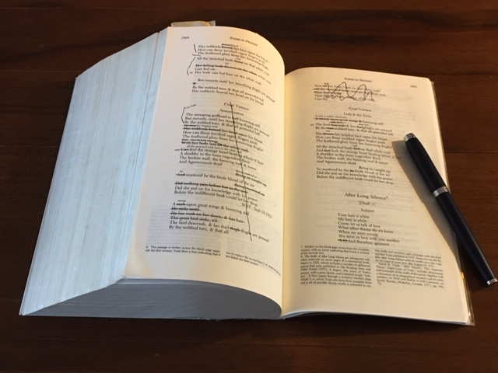
Text 1 – W. Shakespeare (1564-1616): Sonnet 18
To be found for example on https://www.poetryfoundation.org/poems/45087/sonnet-18-shall-i-compare-thee-to-a-summers-day
Text 2 – Christina Rossetti (1830-1894): No, Thank You, John

To be found for example on https://www.poetryfoundation.org/poems/146808/no-thank-you-john

Text 3 - W.H. Auden (1907-1973): Funeral Blues

To be found for example on https://medium.com/poem-of-the-day/w-h-auden-funeral-blues-8771e2868595

Text 4 – June Jordan (1936-2002): Apologies to All the People in Lebanon

To be found on https://www.poetryfoundation.org/poems/48757/apologies-to-all-the-people-in-lebanon

