Short story project

4 Havo

Tim Visscher

Griftland College

Contents
Rules of play 3
Compulsory learning materials 3
Course description 4
Leerdoelen 4
Toetsing 4
Werkwijze 4
Succesfactoren 5
Course Planner 6
Fear | Stories 8
The Elevator – William Sleator 8
The Clock – W.F. Harvey 8
The Boarded Window - Ambrose Bierce 8
Group Assignments 8
Follow-up 1: Telling the Tale 9
Revenge | Stories 13
Lamb to the Slaughter – Roald Dahl 13
The Cask of Amontillado – Edgar Allan Poe 13
The Return – Fernando Sorrentino 13
Group Assignments 13
Follow-up 2: Constructing the Character 14
Love | Stories 19
Through the Tunnel – Doris Lessing 19
The Nightingale and the Rose – Oscar Wilde 19
Group Assignments 19
Follow-up 3: Writing the Woe 20
Specification of literary terms 21
Rubrics for follow-up assignments 23
Follow-up1 24
Follow-up 2 25
Follow-up 3 26
Presentation details 27
Presentation Rubric 28
Spare worksheets 29
Worksheet 1: Plot 30
Worksheet 2: Setting 34
Worksheet 3: characters 38

Rules of play

- For English, learning is team-work between you, your classmates and your teacher.
- Bring your module book and other course materials to class. Without them, you can’t work.
- Keep module books and classroom work in an organised file.
- Any lost materials will have to be reprinted on at your own expense.
- Coursework during the learning process is submitted through Microsoft Teams
- Final versions of your work for grading are always submitted according to the instructions in the Course Description. Work submitted otherwise will be regarded as not submitted.

Compulsory learning materials

Course description

Leerdoelen

Hoofdleerdoel | Ontwikkelen van de literaire leesvaardigheid in Engelse korte  verhalen.
Ondergeschikte leerdoelen | De leerling leert literaire begrippen en concepten te omschrijven, toe te passen, en te gebruiken bij het maken van een creatief product.  De leerling maakt kennis met verschillende korte verhalen.  De leerling leert beargumenteren m.b.v. de argumentatiedriehoek. De leerling leert literatuurgenres herkennen en indelen.
Leervaardigheden | De leerling leert werkt aan zijn/haar planvaardigheid.  De leerling werkt aan zijn/haar leesvaardigheid en begrijpend lezen. De leerling werkt aan zijn/haar spreekvaardigheid.  De leerling werkt aan zijn/haar vaardigheden om concepten vorm te geven in beeld, vorm en geluid.  De leerling breidt zijn/haar vocabulaire uit.  De leerling ontwikkelt taalbewustzijn.

Toetsing

Moduletoetsen
Toetsvorm(en) | 3 praktische, individuele opdrachten  1 schriftelijke toets
Beoordeling | Toets (cijfer 1-10) en Presentatie (cijfer 1-10)
Inleverinstructie | Follow-up opdrachten: Poster en brief fysiek, podcast op  Microsoft Teams. Uitwerkingen van de opdrachten op Microsoft Teams.
Deadlines | Door de docent zelf te bepalen n.a.v. het persoonlijk rooster
Overige activiteiten en toetsen deze periode
Vaardigheidstraining | Talenlab Luva (luistervaardigheid)
Vaardigheidstoetsen | Luva (p3), eventueel Leva (p2) indien nodig.

Werkwijze

Werkvorm | Verhaalanalyses: groepswerk | Follow-ups:  individueel/groepswerk
In de les | Groepswerk en individueel werk
Buiten de les | Groeps- en individueel werk

Succesfactoren
Lees elke keer je verhaal grondig en belééf het verhaal als een film. Plak tijdens het lezen tabjes, markeer woorden en zoek betekenissen op. Op deze manier dwing je jezelf om bewust met het verhaal bezig te zijn en daarmee leer je en kan je alles beter onthouden.
Maak alle opdrachten door ze te bespreken met je groepje, verdeel geen inhoudelijk werk!! Je hebt elkaars inzicht nodig. Controleer of je de literatuurdriehoek gehanteerd hebt bij je antwoorden en wees kritisch naar elkaar.
Organiseer al je papierwerk goed: je krijgt veel los papier (losse verhalen, eigen bevindingen, aantekeningen, etc.) en je raakt gemakkelijk iets kwijt. Stop alles in je map zodat je het ook weer bij de hand hebt wanneer je gaat voorbereiden voor de toets.

Course Planner
Week | Subject | Literary Focus | In class | Group work | Individual work
4 | Fear | Plot Setting | Course introduction  Instruction plot & setting  Reading: The Elevator  Choose story for next week. | Work on general tasks and type out at home. | Buy tabs, marker and file. Read story
5 |  |  | Group assignments for chosen story | Work on general tasks in class  and type out at home. | Read story  Work on assignments
6 |  |  | Follow-up 1  Choose story for next week. | Complete general tasks and make ready for submission. Complete follow-up 1 and  bring to class. | Submit general tasks in Teams.
7 | Revenge | Characters | Instruction Characters  Group assignments for chosen story | Work on general tasks in class and type out at home. | Read story  Work on assignments
8 |  |  | Follow-up 2  Choose story for next week. | Complete general tasks and make ready for submission. | Complete follow-up 2 and bring to class.  Submit general tasks in Teams.
9 | BREAK
10 | Love | Point of View Theme Message | Follow-up 3  Prepare for test week.  NB: instructions on literary terms and the general assignments are homework. | Instructions Point of View, Theme and Message.  Group assignments for chosen story. Complete general tasks. | Read story  Work on assignments. Complete follow-up 3 and bring to class.  Submit general tasks in Teams.
11 | Test week (starting Monday 11/03/2019, ending Tuesday 19/03/2019)
12/13 | Presentations / Miscellaneous

Fear | Stories

The Elevator – William Sleator
Martin, twelve-years-old, has moved to an apartment building with an old, small elevator. He wants to avoid it, but he lives on the seventeenth floor and doesn’t want to look like a coward. One morning an unusual lady rides the elevator with him, increasing his sense of dread.

The Clock – W.F. Harvey
A man is asked by an elderly woman, who’s been staying with his aunt after her servants abruptly left her, to retrieve a travel clock from her abandoned mansion.

The Boarded Window - Ambrose Bierce
A man named Murlock is found dead in his cabin and is buried close to it, next to his wife. However, these are the only known facts of the story, and there are some whispers about what actually happened.

Group Assignments
General individual assignments
 Read the story.
While reading, paste tabs to mark important parts of the story that you may need later on.Keep track of vocabulary you don’t know by marking those words and looking them up on Collins Dictionary. Write the word’s meaning in the page margin.

Specific group assignments
- Plot
Fill in the Freytag-pyramid (worksheet 1) by describing what happens in the story for each of the phases.
- Setting
Describe the setting of your story in worksheet 2.

Follow-up 1: Telling the Tale
“For me, the sound design and the musical score is a big part of what makes scary movies work.”
-James Wan-
Director/Producer of Saw, Insidious, The Conjuring, Annabelle, and many others.
  - What?
    - You are going to re-tell the story your group chose for this theme in the form of a Sounds Effects Radio Show” in which you combine speech with sounds and music. This involves…
      - Planning the work
      - Dividing tasks
      - Summarizing the story
      - Creating a script
      - Finding sounds and music
      - Recording your show
  - How?
    - You work with all the people in your study group. (3 – 4)
    - The length of the show needs to be in-between 2 and 3 minutes
    - You hand in your show as an mp3 file through Microsoft teams.
    - Make sure to check the audio’s quality so everything is understandable
  - Why?
    - You and your group members show that you understand the story’s plot and narrative structure.
    - You and your group members demonstrate how to build suspense and setting through combining speech with sounds and music
    - You and your group members work on your executive skills such as planning, group work, digital skills, and time-management
    - You and your group have fun! ☺
  - Helpful info.
    - You can find great background music and sounds through google and YouTube
    - You can either record everything at once, using ‘real’ sounds, or use programs such as Audacity to create your mp3
    - Example of a Sound Effects Story: https://www.youtube.com/watch?v=sULkdmWA400
    - Examples of short yet scary Sound Effects Stories:
https://www.youtube.com/watch?v=smN5fB_ROO0
    - The importance of sounds:
https://www.youtube.com/watch?v=UO3N_PRIgX0
    - An easy way: https://youtu.be/3jbNpGQnTQI

Worksheet 1: Plot

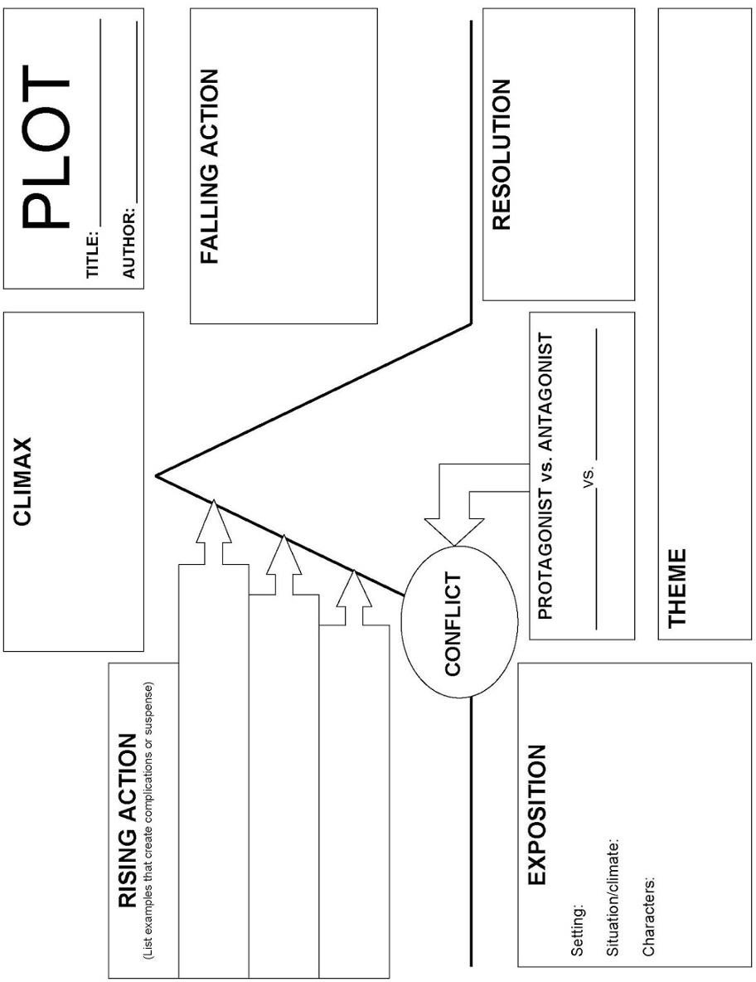

Worksheet 2: Setting
IMPORTANT: Always provide multiple quotes to support your answers.

Where does the action in the story take place? | The bigger picture: what environment/culture/country and temporal  and temporal setting might you place your story?
Story-time: how long does the entire story take? | Discourse-time: what parts in the story take up a lot of time? Why would that be?

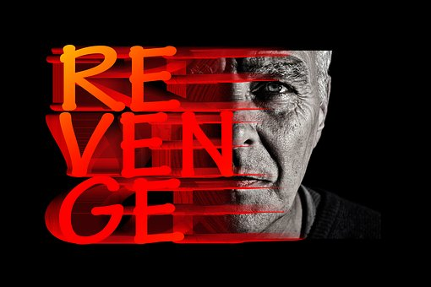

Revenge | Stories

Lamb to the Slaughter – Roald Dahl
The marriage of a happy couple takes an unforeseen turn to the worse when the husband comes home with a bad tiding.

The Cask of Amontillado – Edgar Allan Poe
Montresor has been seriously insulted by his friend Fortunato and seeks revenge. In his attempt to execute his revenge, he tries to make use of his friend’s good confidence.

The Return – Fernando Sorrentino
A man, studying to become a high school teacher witnesses a confusing series of events that leave him and us with lots of questions.

Group Assignments
General individual assignments
 Read the story.
>While reading, paste tabs to mark important parts of the story that you may need later on.
>Keep track of vocabulary you don’t know by marking those words and looking them up. Write the word’s meaning in the page margin.
General group assignments
- Plot
Fill in the Freytag-pyramid (worksheet 1) by describing what happens in the story for each of the phases.
- Setting
Describe the setting of your story in worksheet 2.

Specific assignments
- Focus on the three most important characters in the story.
Analyse each of these characters on a separate worksheet. See worksheet 3.
- For the main character, describe if you could relate to him/her. Explain why you could/couldn’t relate and describe at least two examples from the story to prove your point.

Follow-up 2: Constructing the Character
“There are lots of unlikeable characters in literature. It doesn’t mean they’re not fascinating”
-Lynne Tillman-
Novelist, short story writer, and cultural critic.
  - What?
    - You are going to create one character poster with at least two characters from the story of your choice. This poster needs to vividly display the characters’ inside, outside, and relevance to the plot. Think, for example, of displayed objects, facial expressions, placement, major plot details, etc. Use the character worksheet to get started.
  - How?
    - You will do this assignment individually.
    - You are allowed to choose between crafting your poster or creating a photograph. Mind that the photograph needs to be properly edited to succeed.
    - You hand in your work on paper. When choosing a photograph, you hand it in in coloured print.
    - You will also write a brief justification of at least 6 of your choices, i.e. why certain colours, why certain placements, etc.
  - Why?
    - You demonstrate that you understand different character layers.
    - You learn the skill of visually expressing characteristics and story details
    - You show that you can find and express the most important plot details.
  - Helpful info.
    - Google some character posters from your favourite film, game or television series. Find out how they represented your character, such as below
    - Use your character worksheet to inspire your poster
    - How to create a movie poster: https://www.youtube.com/watch?v=skPfWfuYn3A
    - Are you lost? Go back to the story and highlight the characters’ descriptions
    - Remember: you also get to know a character through his/her actions!

Worksheet 3: character

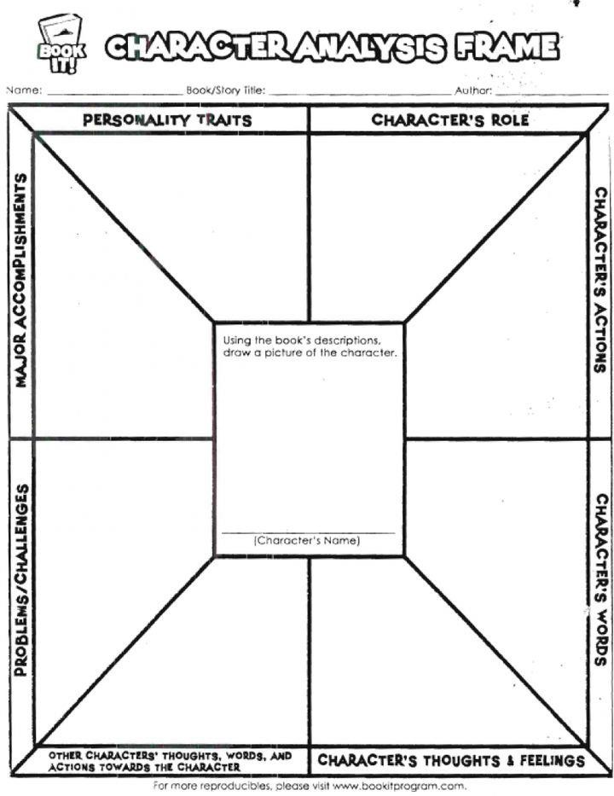

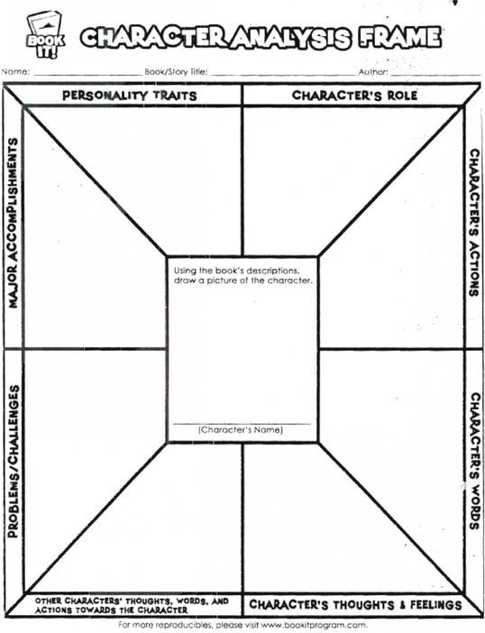

Love | Stories

Through the Tunnel – Doris Lessing
Jerry and his mother go on holiday to a beach resort. During the holiday both mother and Jerry learn a lot about the flaws of parental love.

The Nightingale and the Rose – Oscar Wilde
A woman promises a boy that she’ll dance with him at the ball if she brings him a red rose. The boy doesn’t have any red roses. A nightingale comes to the rescue but the story ends in tragedy.

Group Assignments
General individual assignments
 Read the story.
>While reading, paste tabs to mark important parts of the story that you may need later on.
>Keep track of vocabulary you don’t know by marking those words and looking them up on Collins Dictionary. Write the word’s meaning in the page margin.
 Summarize the story in 10-15 lines. Focus on the most important events in the story.
General group assignments
- Plot
Fill in the Freytag-pyramid (worksheet 1) by describing what happens in the story for each of the phases.
- Setting
Describe the setting of your story in worksheet 2.
- Focus on the three most important characters in the story.
Analyse each of these characters on a separate worksheet. See worksheet 3.
- For the main character, describe if you could relate to him/her. Explain why you could/couldn’t relate and describe at least two examples from the story to prove your point
Specific assignments
- Point of view: Decide the point of view in your story. Explain your choice for a point of view and provide 3 clear examples from the story to prove your point.
- Theme: In what way does love impact the main character? What does the main character learn about love in his life?
Write down the theme as 1 sentence:
- How a boy/man learns that …
- Message: both of this week’s stories have a hidden message to the reader. Discuss in your group: what would the writer like to teach us about love in this story? Write down your answers.

Follow-up 3: Writing the Woe
“Perhaps one did not want to be loved so much as to be understood.”
-George Orwell-
Writer of Nineteen-eighty-four and Animal Farm.
  - What?
    - You are going to create an (un)romantic ‘love letter from either Jerry’s (Through the Tunnel) or the young student’s (The Nightingale and the Rose) point of view. You will use the information about the character’s opinion of
love and romance. You ‘write off’ the frustrations or happiness about the love he has or hasn’t received as if you are him. You will create a handwritten letter that fits this opinion. All this involves several steps:
      - Decide what you think is the character’s view on love (use the specific questions)
      - Look up examples to support this character’s view in the story
      - Think of the tone you want to write the letter. Will it be, for example, angry, sad, happy or perhaps annoyed?
      - Think of a way to not only represent this tone in your words, but also in your handwriting. What does an angrily written letter look like, or what happens when you are crying while writing a letter?
      - Write your draft letter and ask a fellow student or your teacher for possible improvements
      - Write your final letter.
  - How?
    - This assignment is done individually
    - The letter has to be in-between 200 and 250 words.
    - The letter needs to be handwritten and your choice of lettering and the appearance of the letter should fit its content.
    - The handwriting should fit the story’s theme.
    - You hand in your letter in class.
  - Why?
    - You practice and improve your writing skills
    - You demonstrate your knowledge of the chosen story
    - You show that you understand Point Of View
    - You put the story’s theme and message to practice and with that demonstrate you both understand it and can work with it.
    - You show your understanding of the story by both writing and creating visuals (in this case the visuals are your handwriting, the way the letter looks, and perhaps other details that are in your letter
  - Helpful info.
    - When running out of word inspiration: www.thesaurus.com
    - Google for different types of handwriting to inspire your work.

Plot

Specification of literary terms

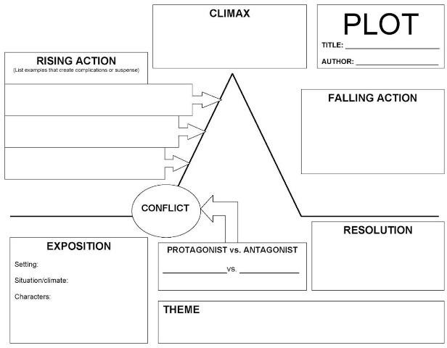
The sequence of interrelated events in a story, novel, film or play. Often exposed in a plot diagram following 5 or 6 stages:
- introduction
- initial incident
- rising action
- climax
- falling action
- conclusion

Setting
The place, type of surroundings in which a story takes place. A writer makes a deliberate choice for a specific or unspecific setting. This is important as it affects the way we understand the story.
Under setting we consider:
- time frame: the specific period a story is set in, and the way life in that age affects the story and characters.
- place: what country or countries, towns or streets the story is (possibly) set in.
- Social setting: does the character or do characters belong to a certain social group, minority (Native Americans, Irish, etc.) or social class (working class, middle class or upper class).

Characters
All the people or things that play a role in the story. Characters can be divided in main characters, and secondary characters. The main character is usually the person the story revolves around. Usually a character interacts with other characters. Important to know is whe interaction between the following roles:
- Protagonist: the main character in the story, the person the story revolves around.
- Antagonist: a main character who helps the protagonist, or works against him.
- Third: the person or thing that influences both the protagonist and the antagonist.

Point of view
Stories are usually told from a narrative perspective. Below are the most commonly found narrative perspectives:
- First person narrator: story is told from the perspective of an I-person.
- Third-person omniscient narrator: story is told through a third person that has complete knowledge about all the other characters in the story.
- Third-person limited: story is told through a third person that has only limited knowledge of what the other characters think and do.

Theme
The theme of a story is usually about how the topics in a story influence the main character or characters. So if a topic is, for instance: ‘life in a Warsaw ghetto in World War II’ the theme could be: ‘How a Jewish man learns to survive in a Warsaw ghetto in World War II’.

Message

The message of a story is the thing a writer wants us to learn or think about after or while reading. Also, it is often closely related to the theme but should also be applicable to your own life.

Rubrics for follow-up assignments

For all rubrics, please see the next pages.

Follow-up1 | Poor | Sufficient | Good | Excellent
Pronunciation | Unclear: mispronounces multiple words and/or strong foreign accent, affecting comprehension and/or mumbles / slurs  / skips syllables multiple times. | Mostly clear: mispronounces no more than a few words and/or rather strong foreign accent, some effect on comprehension. | Clear: words all pronounced correctly / very few errors. Slightly foreign accent, no effect on comprehension. Effective. | Speaks clearly and distinctly all of the time (crisp) and does not mispronounce any of the words. Clear hint of native speaker-like English. Convincing.
English Grammar & Vocab | Many words in grammar / word use, affecting understanding. Lots of Dutch words / Dunglish. | Quite some mistakes in grammar & word use, hampering understanding regularly. Several instances of Dutch words /  Dutchisms. | Some mistakes in grammar & word use, not affecting understanding. A few Dutchisms. | Hardly any mistakes in grammar & word use. No effect on understanding. No Dutchisms.
Plot knowledge | You do not understand the story’s plot whatsoever. You don’t tell the actual story. | Facts and fragments from the story are presented, but in the wrong order OR missing key elements from plot. | Good knowledge of plot. The key elements of the plot are presented in the right order. | Extensive knowledge of the  story’s plot: key elements of the plot are presented in the right order + plot / setting details.
Story’s Setting and Suspense Representation through sounds and music | The key elements of the plot are presented in the right order. Music and sounds used create the wrong setting / atmosphere. No creation of suspense. OR No sound effects and/or music at all. | At least 3-4 different sound effects  / sounds to create the story’s setting. At least 1 score to create a fitting atmosphere. Sounds and music not completely convincing in creating a sense of suspense. | At least 5-6 different sounds to create the story’s setting At least 2 different scores to create a fitting atmosphere.  The sounds and music fit nicely and create a convincing sense of suspense. | 6 or more different sounds to create the setting of the story. At least 3 different scores to create a fitting atmosphere. The sounds and music fit very well and create a convincing sense of suspense.
Story’s Setting and Suspense Representation through use of voice | Hardly any variation in intonation, volume, pace and/or pauses. | Not yet convincing: some suspense through varying intonation / volume / pace / pauses. | You demonstrate good knowledge on the story’s suspense through varying  intonation / volume / pace / pauses. Quite convincing. | You demonstrate excellent knowledge on the story’s suspense through varying intonation / volume / pace /  pauses. You are convincing at all  times.
Running Time | The duration of your Mp3 is less than 2 minutes.  (too short) | The duration of your Mp3 is 2.00 -  2.20 minutes. | The duration of your Mp3 is  2.20 - 2.40 minutes. | The duration of your Mp3 is 2.40  - 3.00 minutes.

Follow-up 2 | Beginner | Working towards | Expected standard | Greater depth
Plot details | The poster only shows very few plot details and it is unclear which story the poster is about. | The poster shows details of the story’s plot, but it is not clear if they are the most important parts. | The poster shows important details of the story’s plot quite literally and also a bit through visual aids. | The poster shows all the important details of the story’s plotline through  several different visual aids such as placement of  characters, the use of familiar objects, colours, etc.
Character details | The poster only shows very few character details and it is unclear which characters the poster is about | The poster shows details of the characters but lacks details on their personality. | The poster shows important details of the characters and their personalities quite literally and also a bit through visual aids. | The poster shows all the important character traits through several different visual aids such as placement, use of familiar  object, colours, etc.
Creativity | Poster lacks creativity.  Nothing extra is done to  reach the assignment’s goals | Poster shows some creativity in that some effort has been made by making unexpected decisions that work for  reaching the assignment’s goals. | Poster is very creative by  using ‘out of the box’ choices that work for reaching the assignment’s goals | Poster is very creative. Lots of ‘out of the box choices’ and unexpected decisions have been made and everything works for  reaching the assignment’s goals.
Justification | Justification is missing | Justification is present, but incomplete and/or too brief | Justification is present, clear and uses one or two references which explain  certain choices | Justification is present, clear, correct, and extensively explains choices by using  references.
Hand in details | Poster is in bad condition (messy, unclear, not in one  piece, etc.) and handed in after the deadline. | Poster is in so-so condition (messy but still in-tact, etc.) but handed in on time. | Poster is in good condition (clear, visible, in one piece, etc.) and handed in on time. | Poster is in very good condition, handed in on  time, and produced with quality materials.

Follow-up 3 | Beginner | Working towards | Expected standard | Greater depth
Story-specific knowledge | Hardly any information from story used in letter. | A minimum amount of information from story used in letter. | Elements of information from the story are referred to in letter. | Elements of information from story are meaningfully manipulated in the letter.
Story-specific love | Letter doesn’t fit type of love explored in story. | Letter superficially fits type of love explored in story. | Letter fits the type of love explored in the story. | Letter shows insight to the type of love explored in the story.
Writing style | Impersonal, distant or inappropriate writing style. | Partially successful attempt of a personal writing style showing a degree of intimacy between author and recipient. | Attempt of a personal writing style showing a degree of intimacy between author and recipient. | Personal writing style showing a degree of intimacy between author and recipient.
Communicative efficacy | Reading experience severely affected by countless inaccuracies. | Reading experience sometimes affected by inaccuracies present. | Pleasant reading experience with some inaccuracies present. | Advanced reading experience with some inaccuracies present.

Presentation details
You are going to give a presentation in which reflection on your progress is the central theme. You will reflect on yourself, the work you’ve done, the products you have produced, how did you prepare for the test, etc.

The questions will help you design your presentation. Just follow the steps! Make sure you take your time and read all the instructions thoroughly. Don’t forget that we expect a full 3 minute presentation so be elaborate.

Before you start, here is a list with the most important details.

•  •  • | Main theme:  Length: Mode: | Reflection on your progress 3 minutes  Individual
• | PowerPoint: | Yes (only as a visual aid, supporting your spoken story)
• | Language: | English (obviously)
• | Assessment: | Rubric / grade 1-10

Your presentation should contain clear and coherent answers to the following questions.

- What have you learnt from the follow up assignments?
  - Explain the process of making the podcast (what was your task?) and what this taught you.
  - Explain your poster and tell us what choices you made and why. Also, add what you’ve learnt.
  - Explain how your letter represents the story’s main theme.
- How did your English skills improve? Give at least 3 different aspects.
i.e. “what can you do now that you were not able to do at the start of the second term?
Why?” Or, “which skills improved? i.e. reading/listening/writing/etc. Why?”
- What was your favourite story? Why?
  - Use at least three of the following aspects:
plot / setting / characters / theme / message
and make sure you provide examples from the story.
- How did you prepare for the test? “Studying hard” is NOT a sufficient answer!

Please note that your teacher has seen your work, observed your work-ethics, and knows you. This means your teacher expects a trustworthy and personal reflection on your work.

Presentation Rubric

Spare worksheets
For all worksheets, please see the next pages

Worksheet 1: Plot

Worksheet 2: Setting
IMPORTANT: Always provide multiple quotes to support your answers.

Where does the action in the story take place? | The bigger picture: what environment/culture/country and temporal  and temporal setting might you place your story?
Story-time: how long does the entire story take? | Discourse-time: what parts in the story take up a lot of time? Why would that be?

IMPORTANT: Always provide multiple quotes to support your answers.

Where does the action in the story take place? | The bigger picture: what environment/culture/country and temporal and temporal setting might you place your  story?
Story-time: how long does the entire story take? | Discourse-time: what parts in the story take up a lot of time? Why would that be?

IMPORTANT: Always provide multiple quotes to support your answers.

Where does the action in the story take place? | The bigger picture: what environment/culture/country and temporal and temporal setting might you place your  story?
Story-time: how long does the entire story take? | Discourse-time: what parts in the story take up a lot of time? Why would that be?

IMPORTANT: Always provide multiple quotes to support your answers.

Where does the action in the story take place? | The bigger picture: what environment/culture/country and temporal and temporal setting might you place your  story?
Story-time: how long does the entire story take? | Discourse-time: what parts in the story take up a lot of time? Why would that be?

Worksheet 3: characters

Worksheet 3: character

Worksheet 3: character

Worksheet 3: character

